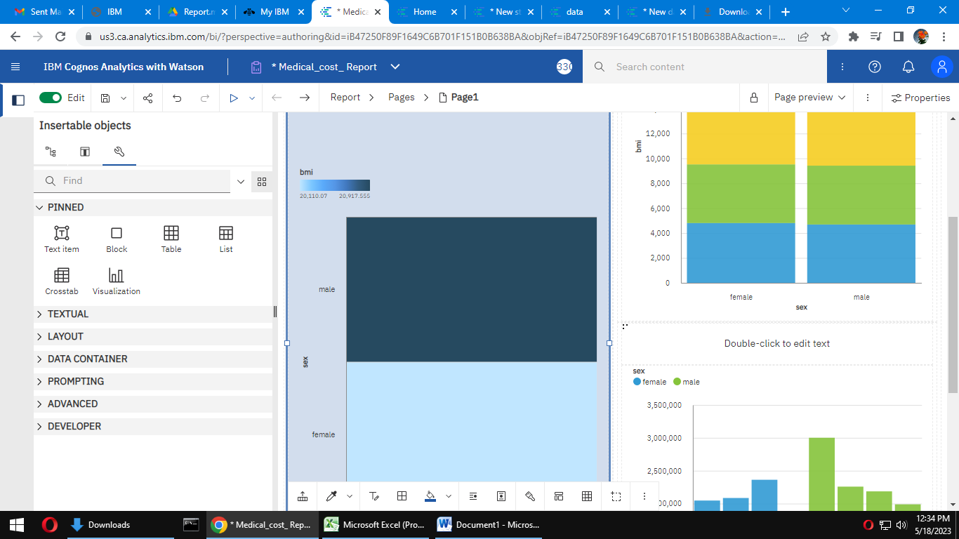

Link: <https://us3.ca.analytics.ibm.com/bi/?pathRef=.my_folders%2FMedical_cost_%2BReport&action=edit>